- Frequency/Distribution Plots

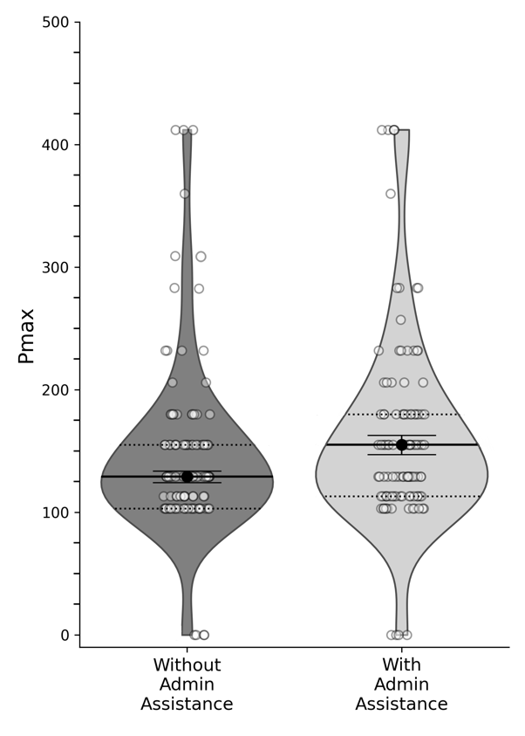
Non-Doctoral Clinicians Phd/PsyD Clinicians

Note. The points represent the pmax values for each group, with the dark dot in the violin plot indicating the median value. The surrounding lines represent the 95% confidence intervals, while the dashed lines mark the interquartile range (IQR), denoting the first and third quartiles. The width of the violin plot reflects the distribution of frequencies across the data.

- HDT Results Table

HDT Results
Condition | Q0d | K | Alpha | Pmaxa
1st trial (Doctoral Providers) | 18.58 | 0.89 | 0.0003 | 188.97
1st trial (Non-Doctoral Providers) | 15.3 | 0.86 | 0.0004 | 168.51
2nd trial (Doctoral Providers) | 19.42 | 0.93 | 0.0002 | 206.28
2nd trail (Non-Doctoral Providers) | 16.8 | 0.95 | 0.0003 | 207.90

- HDT Wilcoxon Signed-Rank Test
Trial | W | Sig. (p)
1st vs 2nd (Doctoral Providers) | 3460.5 | 0.0252
1st vs 2nd (Non-Doctoral Providers) | 5281.0 | 0.0497

- Criteria Ranking for Doctoral Clinicians

Rankings of Reasons for Not Accepting Medicare
Reason | Mean | Median | Most Common
Reimbursement rates are too low | 2.44 | 2.0 | 1.0
Administrative burden of submitting claims | 2.72 | 2.0 | 2.0
Delays in getting paid | 3.47 | 4.0 | 4.0
Concerns about treatment regulations | 3.45 | 4.0 | 4.0
Concerns about audit risk | 3.74 | 4.0 | 5.0
Not accepted onto an insurance panel | 5.19 | 6.0 | 6.0

Rankings of Reasons for Not Accepting Medicaid
Reason | Mean | Median | Most Common
Reimbursement rates are too low | 2.09 | 1.0 | 1.0
Administrative burden of submitting claims | 2.57 | 2.0 | 2.0
Delays in getting paid | 3.53 | 3.0 | 3.0
Concerns about treatment regulations | 3.59 | 4.0 | 4.0
Concerns about audit risk | 4.07 | 4.0 | 5.0
Not accepted onto an insurance panel | 5.16 | 6.0 | 6.0

Rankings of Reasons for Not Accepting Private Insurance
Reason | Mean | Median | Most Common
Reimbursement rates are too low | 2.08 | 1.0 | 1.0
Administrative burden of submitting claims | 2.72 | 2.0 | 2.0
Delays in getting paid | 3.48 | 3.0 | 3.0
Concerns about treatment regulations | 3.49 | 4.0 | 4.0
Concerns about audit risk | 3.99 | 4.0 | 5.0
Not accepted onto an insurance panel | 5.24 | 6.0 | 6.0

- Criteria Ranking for NON-Doctoral Clinicians

Rankings of Reasons for Not Accepting Medicare
Reason | Mean | Median | Most Common
Reimbursement rates are too low | 2.69 | 2.0 | 1.0
Administrative burden of submitting claims | 2.86 | 2.0 | 2.0
Delays in getting paid | 3.84 | 4.0 | 5.0
Concerns about treatment regulations | 3.35 | 4.0 | 4.0
Concerns about audit risk | 3.82 | 4.0 | 5.0
Not accepted onto an insurance panel | 4.45 | 6.0 | 6.0

Rankings of Reasons for Not Accepting Medicaid
Reason | Mean | Median | Most Common
Reimbursement rates are too low | 2.61 | 2.0 | 1.0
Administrative burden of submitting claims | 2.9 | 2.0 | 2.0
Delays in getting paid | 3.32 | 3.0 | 3.0
Concerns about treatment regulations | 3.6 | 4.0 | 4.0
Concerns about audit risk | 3.76 | 4.0 | 5.0
Not accepted onto an insurance panel | 4.81 | 6.0 | 6.0

Rankings of Reasons for Not Accepting Private Insurance
Reason | Mean | Median | Most Common
Reimbursement rates are too low | 2.5 | 1.0 | 1.0
Administrative burden of submitting claims | 3.07 | 3.0 | 2.0
Delays in getting paid | 3.38 | 3.0 | 3.0
Concerns about treatment regulations | 3.5 | 4.0 | 4.0
Concerns about audit risk | 3.69 | 4.0 | 5.0
Not accepted onto an insurance panel | 4.87 | 6.0 | 6.0

